Practice What You Learnt (Level 2)

PART-1

1. Import and transform the two workbooks - Bank details and Bank details 1.1 - into Power Bi.

* Click on the "Home" tab.
* Click on "Get Data."
* Select "Excel" (since you’re dealing with Excel workbooks).
* Locate and select the first workbook, "Bank details."
* In the Navigator window, select the sheets or tables you want to import from the "Bank details" workbook.
* Click "Load" to load the data directly, or "Transform Data" if you want to make changes in Power Query Editor before loading.
* Repeat the steps to import the second workbook, "Bank details 1.1."

1. Add the third workbook, Bank Details 1.2, into G-drive by simply uploading it.

* Click on "Get Data."
* Select "Web" as the data source.
* In Google Drive, right-click on the "Bank Details 1.2" file and select "Get link."
* Ensure the link sharing setting is set to "Anyone with the link" or "Anyone with the link can view."
* Copy the shareable link.
* Convert the shareable link to a direct download link. Replace the part of the URL from /view?usp=sharing to /export?format=xlsx. For example:
* Original Link: ‘<https://drive.google.com/file/d/FILE_ID/view?usp=sharing>’
* Direct Download Link: ‘https://drive.google.com/uc?export=download&id=FILE_ID’
* In Power BI Desktop, paste the modified link into the "URL" field in the "Web" data source window.
* Click "OK."
* Power BI will access the file from Google Drive and import it.
* You will see the Navigator window where you can select the sheets or tables from the "Bank Details 1.2" workbook.
* Click "Load" to load the data directly, or "Transform Data" if you need to make changes in Power Query Editor before loading.

**3. Present the data following the below criteria by creating the relationships among three workbooks:**

**(3.a) Region-wise number of customers**

* Click on the "Model" icon on the left sidebar to view and manage relationships.
* Drag and drop fields to create relationships between tables. Typical relationships might be:
* **Customer ID** or **Customer Name**: If each workbook contains customer details, you might relate them through a common identifier like Customer ID.
* **Region**: Connect tables based on the 'Region' field to analyze data region-wise.
* **Date/Month**: Link tables by date or month fields if available.
* In the "Visualizations" pane, select the “Pie Chart”.
* Drag 'Region' to the “Legend” area.
* Drag 'Customer ID' or similar field to the "Values" area and set it to "Count."

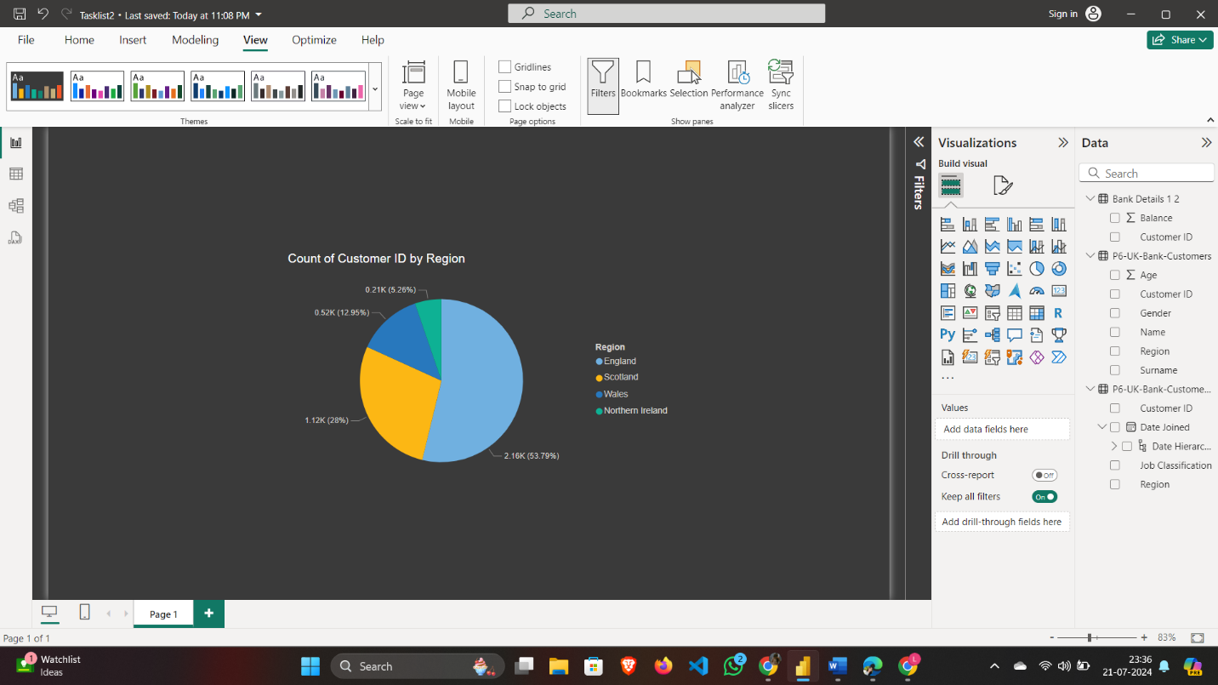

**(3.b) Region-wise number of Male & Female Customers**

* In the "Visualizations" pane, select the "Stacked Column Chart" visual.
* Drag 'Region' to the "Axis" area.
* Drag 'Gender' to the "Legend" area.
* Drag 'Customer ID' to the "Values" area and set it to "Count."

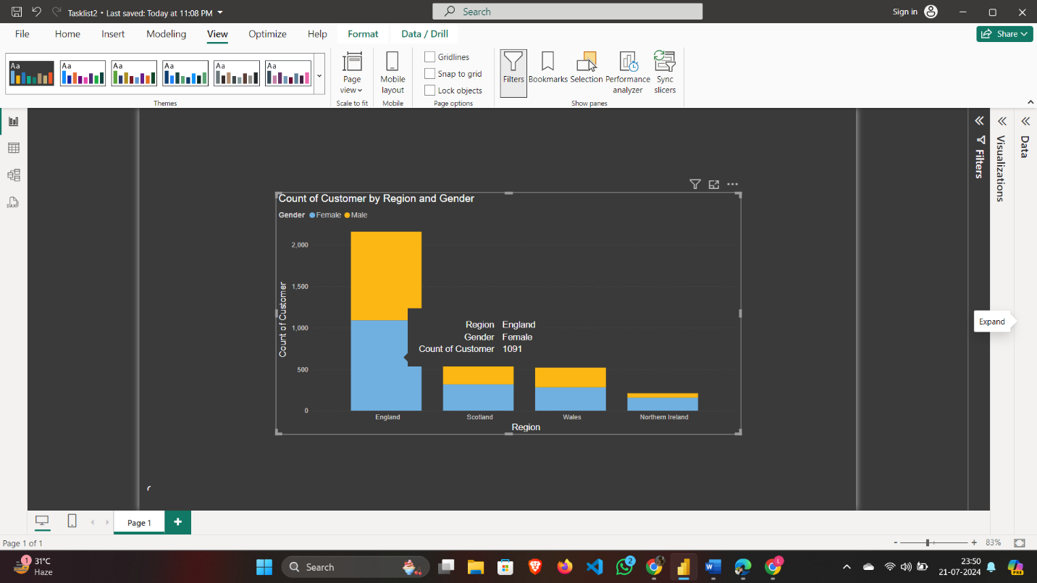

**(3.c) Customer presence throughout the world (based on the region-wise customer base)**

* In the "Visualizations" pane, select the "Map" visual.
* Drag 'Region' to the "Location" area.
* Drag 'Customer ID' or similar field to the "Size" area to represent customer presence.

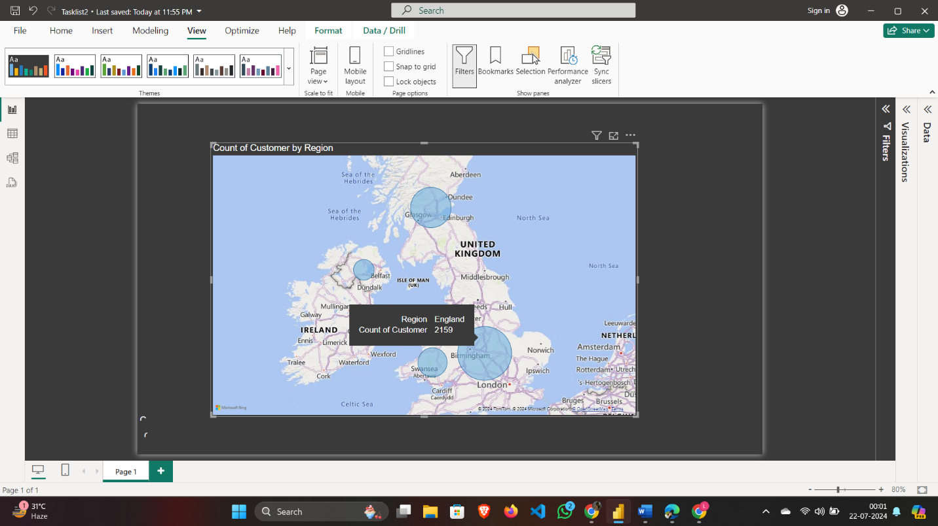

**(3.d) Region-wise customer’s bank balance**

* In the "Visualizations" pane, select the "Stacked Bar Chart".
* Drag 'Region' to the "Y-Axis" area.
* Drag 'Bank Balance' to the "X-Axis" area. Ensure it is set to the aggregation type you need (e.g., Sum).

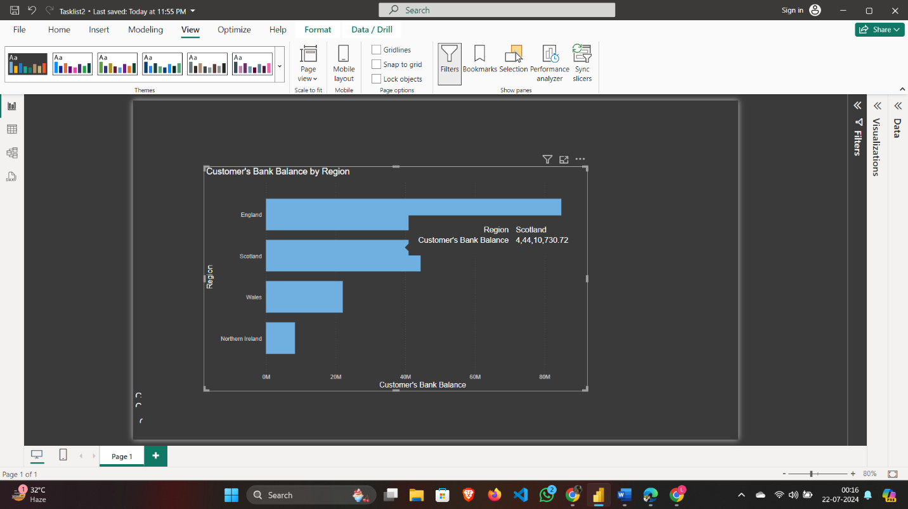

**(3.e) Region-wise Monthly balance availability trend.**

* In the "Visualizations" pane, select the "Line and Stacked Column Chart" visual.
* From the "Fields" pane, drag the 'Date' or 'Month' field to the "X- axis" area.
* Drag the 'Region' field to the "X-axis" area to differentiate by region.
* Drag the 'Bank Balance' field to the "Column Y-axis " area to show the balance amounts.

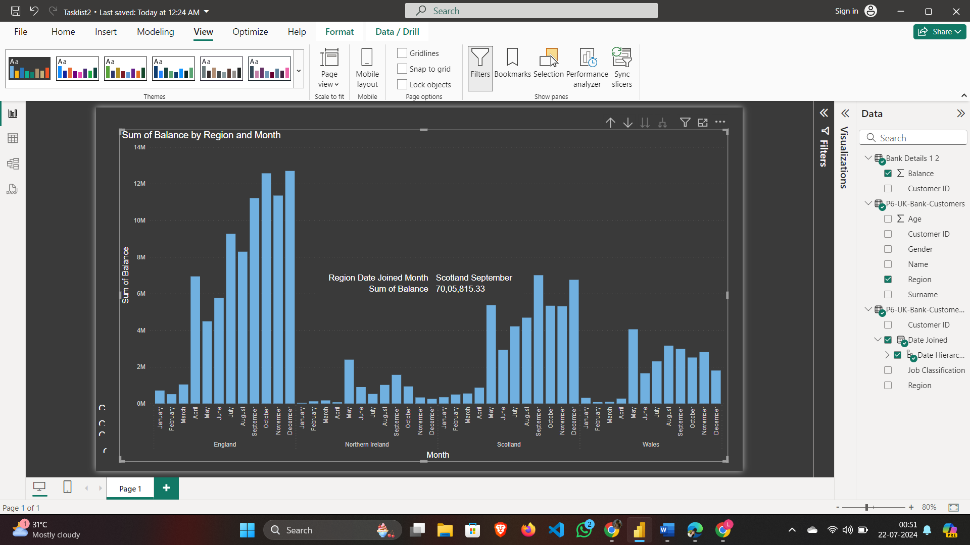

**Final Dashboard will look like:**

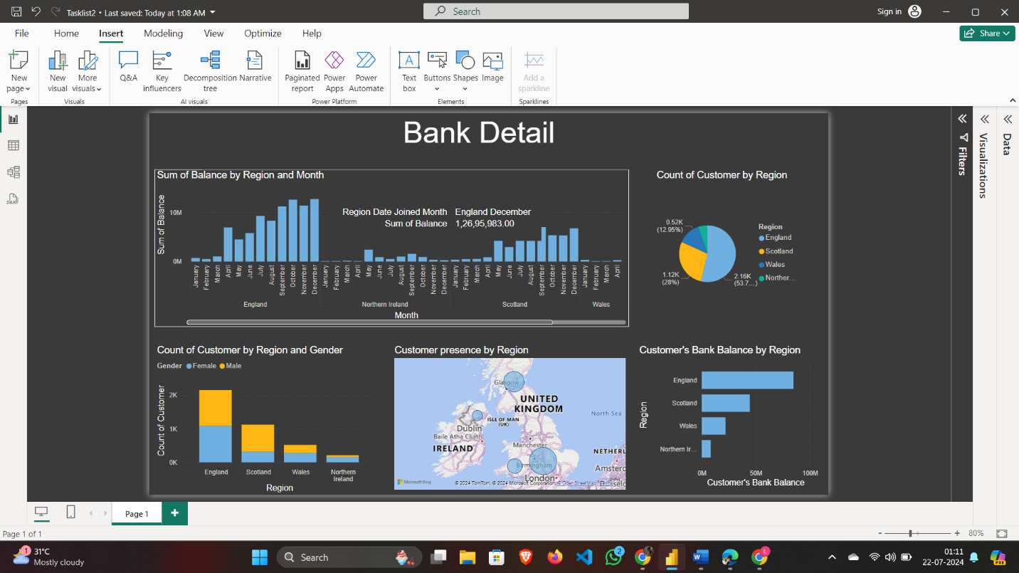

**PART-2**

1. **Import and transform the data from the Sales Data file to Power BI.**

* Click on "Get Data."
* Select "Excel" (assuming your Sales Data file is in Excel format).
* Browse your computer and select the Sales Data file.
* In the Navigator window, select the sheets or tables you want to import from the Sales Data file.
* Click "Load" to load the data directly into Power BI, or "Transform Data" to make changes in Power Query Editor before loading.

**2. Represent the data as per the given criteria:**

**(2.a) Overall profit percentage and commission for sales against each sales representative**

* Click on the "Modeling" tab at the top.
* Click on "New Measure."
* Enter the following DAX formula to calculate the total sales:

Tot Sales = SUMX(Sheet1,Sheet1[Selling Price]*Sheet1[Quantity Sold])

* Enter the following DAX formula to calculate the total profit:

Tot Profit = SUM(Sheet1[Profit])

* Enter the following DAX formula to calculate the profit percentage:

Profit Percentage = DIVIDE([Tot Profit], [Tot Sales]) * 100

* Assuming commission is a fixed percentage of total sales (e.g., 5%), create a measure for commission:

Commission = [Tot Sales] * 0.05

* In the "Visualizations" pane, select the "Matrix" visual.
* Drag 'Sales Rep' to the "Rows" area.
* Drag the measures 'Tot Sales,' 'Tot Profit,' 'Profit Percentage,' and 'Commission' to the "Values" area.

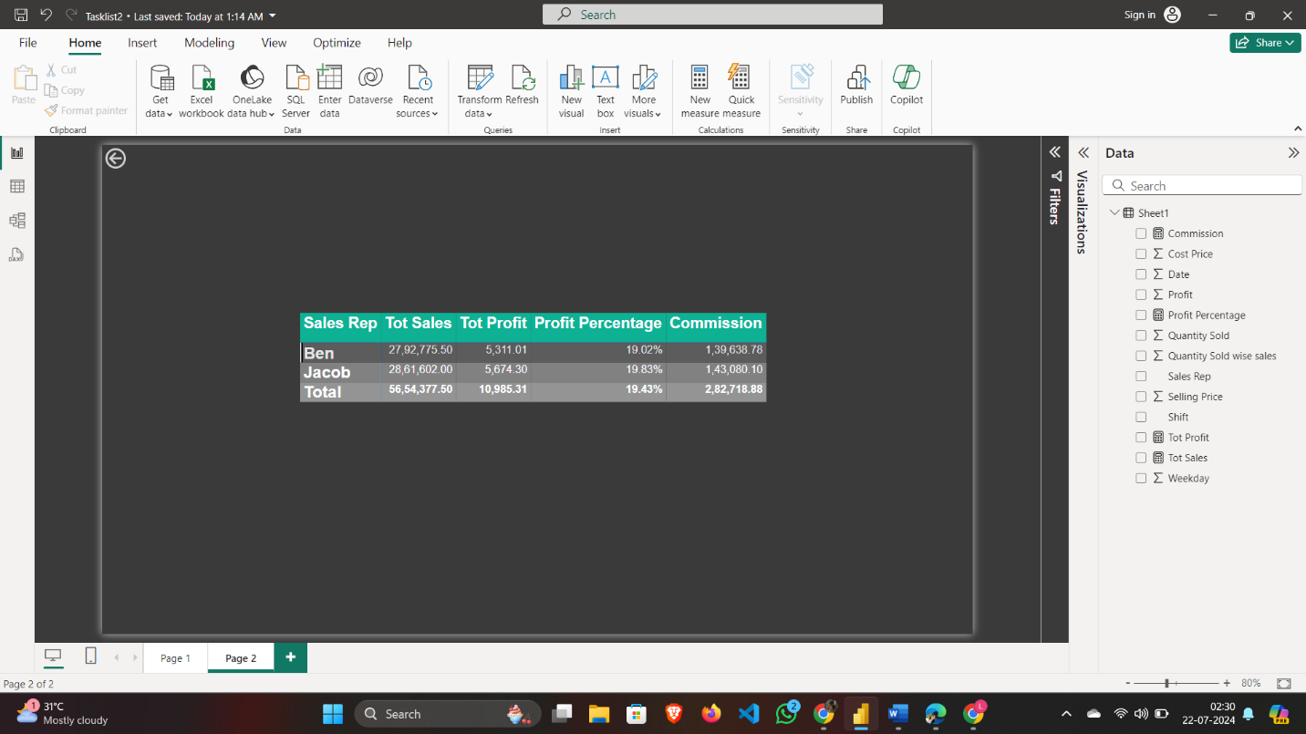

(2.b) **Sales representative-wise total number of work shifts (monthly basis) and work shifts (day & night) trends against the sales representative**

* Click on "New Measure."
* Enter the following DAX formula to count the total work shifts:

Total Work Shifts = COUNT('Sheet1'[Shift])

* Enter the following DAX formula to count the day shifts:

Day Shifts = CALCULATE(COUNT('Sheet1'[Shift]), 'Sheet1'[Shift] = "Day")

* Enter the following DAX formula to count the night shifts:

Night Shifts = CALCULATE(COUNT('Sheet1'[Shift]), 'Sheet1'[Shift] = "Night")

* In the "Visualizations" pane, select the "Line and Stacked Column Chart" visual.
* Drag 'Sales Rep' to the "X- axis" area.
* Drag 'Date' to the "Column Legend" area. Ensure the 'Date' field is set to display months.
* Drag the 'Total Work Shifts' measure to the "Column y-axis" area.
* Drag the 'Day Shifts' measure to the "Line values" area.
* Drag the 'Night Shifts' measure to the "Line values" area as well.

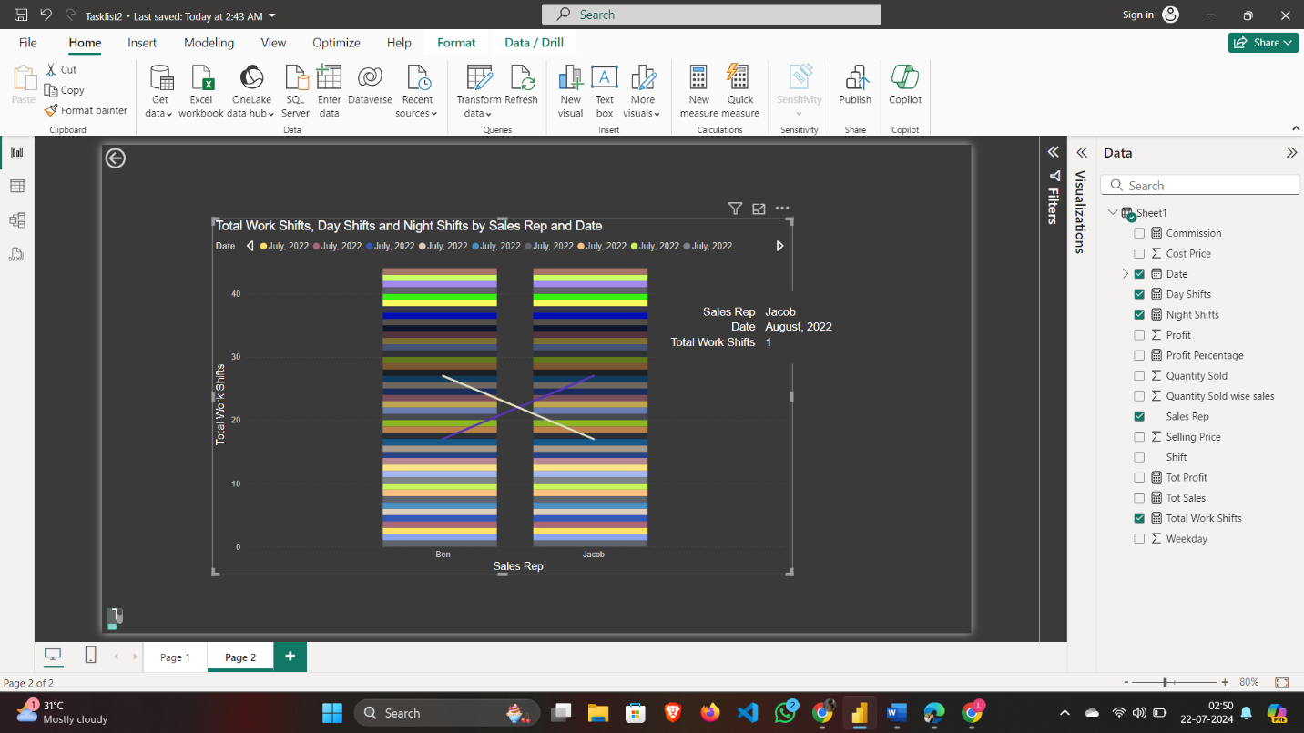

1. **Save the file once done.**

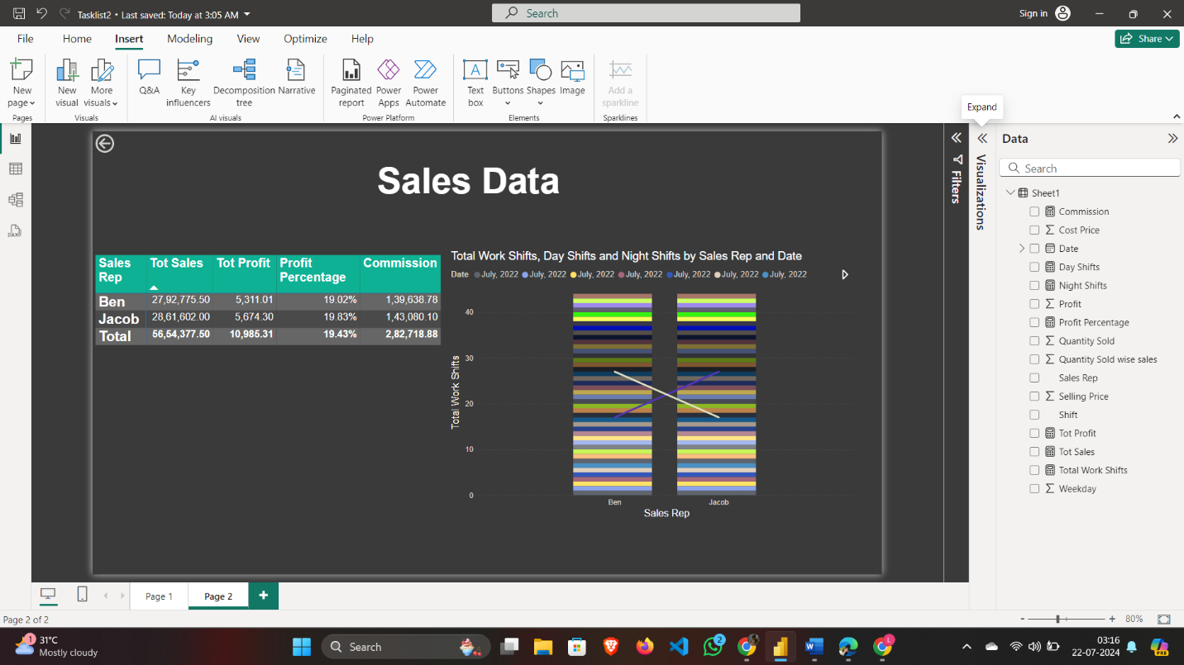

1. **Identify the action items based on the analysis of the Sales Data and write them in the same document:**

**(4.a) What are the areas you find for further improvement in terms of business product sales?**

* Compare the cost price and selling price to ensure a consistent profit margin. Identify any anomalies where the profit margin is significantly lower and investigate the reasons.
* Example: For the date 06-07-2022, the profit margin seems relatively low compared to other dates. Investigate why this happened and how it can be improved.
* Compare the performance of sales reps (Ben and Jacob) based on total sales, profit and quantity sold.
* Example: If Jacob performs better during the day shift and Ben performs better during the night shift, consider scheduling them accordingly.
* Review the pricing strategy to ensure it is competitive and maximizes profit without deterring customers.
* Example: Products sold on 08-08-2022 have a higher cost price but a relatively lower selling price, leading to lower profit margins. Review the pricing strategy for such products.

**(4.b) In which work shift does the sales representative mostly work?**

**Ben**:

Day: 17 times

Night: 27 times

**Jacob**:

Day: 17 times

Night: 27 times

In Conclusion, Ben mostly works the Night shift, while Jacob mostly works the Day shift.

**(4.c) Is there any additional impact you find in business in terms of product sales trend?**

1. **Sales by Shift**:

* **Ben**: Higher number of Night shifts. His sales are significant in terms of quantity sold and total sales during Night shifts.
* **Jacob**: Higher number of Day shifts. His sales are also notable during Day shifts, often with higher profit margins.

1. **Profit Margins**:

* Ben’s average profit per sale appears to be lower compared to Jacob’s, but he compensates with higher sales volume, especially during Night shifts.
* Jacob, with his Day shifts, tends to have higher profit margins per sale, contributing to substantial total profits despite a lower quantity sold compared to Ben.